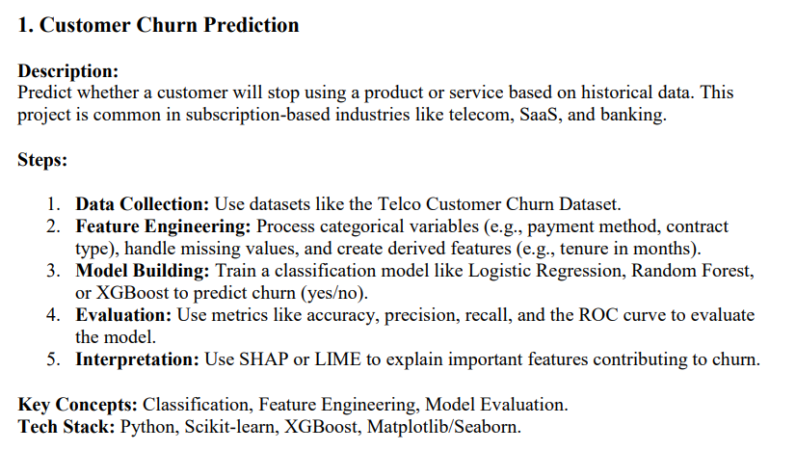

Code:
# Telco Customer Churn Prediction Pipeline
import pandas as pd
import numpy as np
from sklearn.model_selection import train_test_split
from sklearn.preprocessing import LabelEncoder, StandardScaler
from sklearn.linear_model import LogisticRegression
from sklearn.ensemble import RandomForestClassifier
from xgboost import XGBClassifier
from sklearn.metrics import accuracy_score, precision_score, recall_score, f1_score, roc_auc_score, classification_report, roc_curve
import matplotlib.pyplot as plt
import seaborn as sns
import shap
file_path = "/content/WA_Fn-UseC_-Telco-Customer-Churn.csv"
df = pd.read_csv(file_path)
df['TotalCharges'] = pd.to_numeric(df['TotalCharges'], errors='coerce')
df['TotalCharges'] = df['TotalCharges'].fillna(df['TotalCharges'].median())
categorical_cols = df.select_dtypes(include=['object']).columns.tolist()
categorical_cols.remove('customerID')
label_encoders = {}
for col in categorical_cols:
le = LabelEncoder()
df[col] = le.fit_transform(df[col])
label_encoders[col] = le
X = df.drop(columns=['customerID', 'Churn'])
y = df['Churn']
scaler = StandardScaler()
X[['tenure', 'MonthlyCharges', 'TotalCharges']] = scaler.fit_transform(X[['tenure', 'MonthlyCharges', 'TotalCharges']])
X_train, X_test, y_train, y_test = train_test_split(X, y, test_size=0.2, random_state=42, stratify=y)
models = {
"Logistic Regression": LogisticRegression(max_iter=1000),
"Random Forest": RandomForestClassifier(n_estimators=200, random_state=42),
"XGBoost": XGBClassifier(use_label_encoder=False, eval_metric='logloss', random_state=42)
}
results = {}
for name, model in models.items():
model.fit(X_train, y_train)
y_pred = model.predict(X_test)
y_prob = model.predict_proba(X_test)[:,1]
results[name] = {
"Accuracy": accuracy_score(y_test, y_pred),
"Precision": precision_score(y_test, y_pred),
"Recall": recall_score(y_test, y_pred),
"F1": f1_score(y_test, y_pred),
"ROC-AUC": roc_auc_score(y_test, y_prob)
}
results_df = pd.DataFrame(results).T
print("\nModel Performance Comparison:\n", results_df)
plt.figure(figsize=(8,6))
for name, model in models.items():
y_prob = model.predict_proba(X_test)[:,1]
fpr, tpr, _ = roc_curve(y_test, y_prob)
plt.plot(fpr, tpr, label=name)
plt.plot([0,1],[0,1],'k--')
plt.xlabel("False Positive Rate")
plt.ylabel("True Positive Rate")
plt.title("ROC Curve Comparison")
plt.legend()
plt.show()
explainer = shap.TreeExplainer(models["XGBoost"])
shap_values = explainer.shap_values(X_test)
shap.summary_plot(shap_values, X_test, plot_type="bar", show=False)
plt.title("XGBoost Feature Importance")
plt.show()

Results:
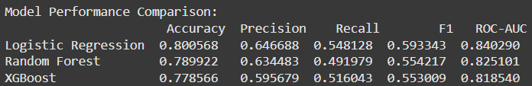
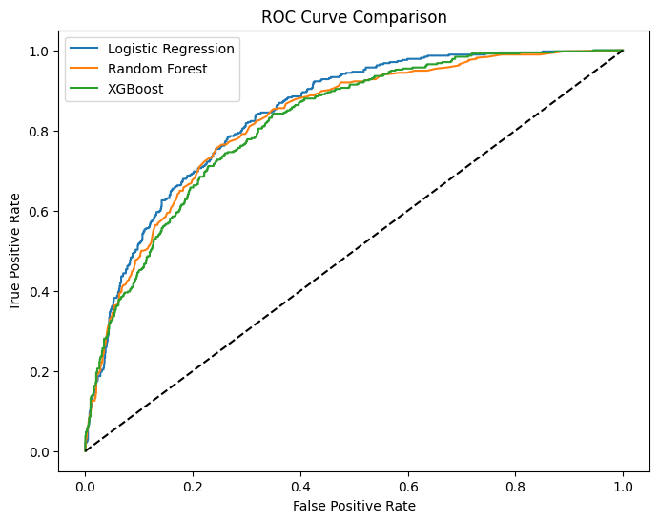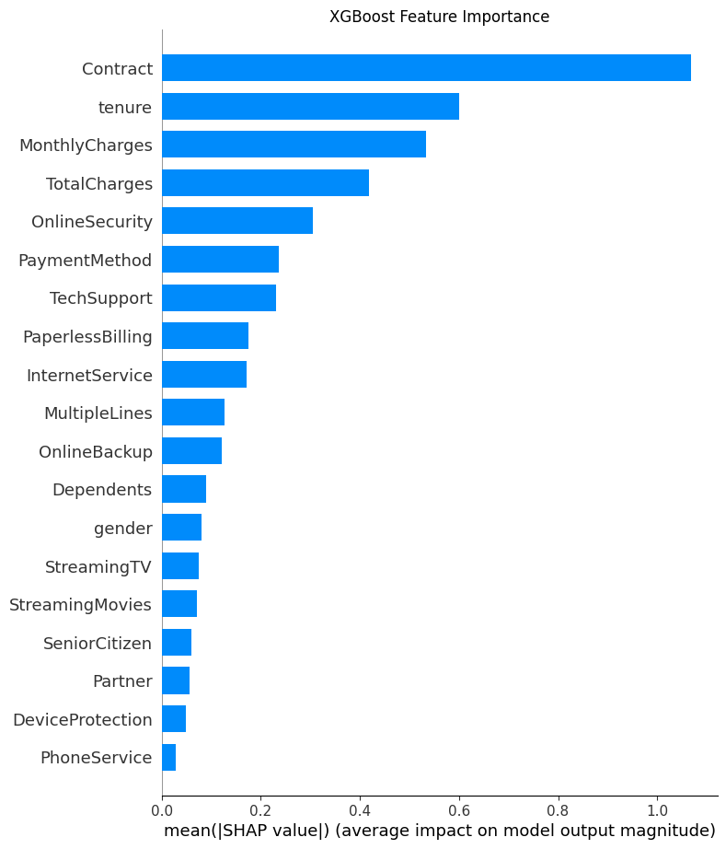
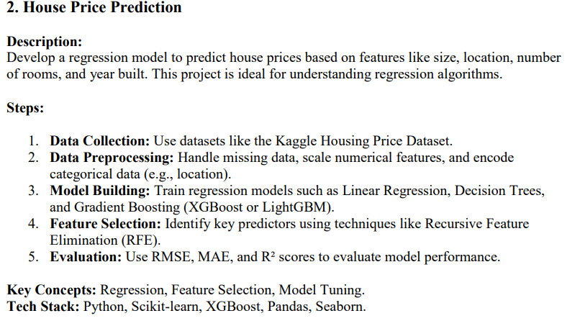Code:
import pandas as pd
import numpy as np
import matplotlib.pyplot as plt
import seaborn as sns
from sklearn.model_selection import train_test_split
from sklearn.preprocessing import StandardScaler, OneHotEncoder
from sklearn.compose import ColumnTransformer
from sklearn.pipeline import Pipeline
from sklearn.metrics import mean_squared_error, mean_absolute_error, r2_score
from sklearn.linear_model import LinearRegression
from sklearn.tree import DecisionTreeRegressor
from sklearn.feature_selection import RFE
from xgboost import XGBRegressor
file_path = "/content/House Price Prediction Dataset.csv"
df = pd.read_csv(file_path)
print("Dataset loaded. Shape:", df.shape)
if 'Id' in df.columns:
df.drop(columns=['Id'], inplace=True)
target = 'Price'
X = df.drop(columns=[target])
y = df[target]
num_features = ['Area', 'Bedrooms', 'Bathrooms', 'Floors', 'YearBuilt']
cat_features = ['Location', 'Condition', 'Garage']
numeric_transformer = StandardScaler()
categorical_transformer = OneHotEncoder(handle_unknown='ignore', sparse_output=False)
preprocessor = ColumnTransformer(
transformers=[
('num', numeric_transformer, num_features),
('cat', categorical_transformer, cat_features)
])
X_train, X_test, y_train, y_test = train_test_split(
X, y, test_size=0.2, random_state=42)
models = {
"Linear Regression": LinearRegression(),
"Decision Tree": DecisionTreeRegressor(random_state=42),
"XGBoost": XGBRegressor(random_state=42, n_estimators=100)
}
results = {}
for name, model in models.items():
pipe = Pipeline(steps=[('preprocessor', preprocessor),
('model', model)])
pipe.fit(X_train, y_train)
y_pred = pipe.predict(X_test)
rmse = np.sqrt(mean_squared_error(y_test, y_pred))
mae = mean_absolute_error(y_test, y_pred)
r2 = r2_score(y_test, y_pred)
results[name] = {"RMSE": rmse, "MAE": mae, "R²": r2}
X_processed = pd.get_dummies(X, drop_first=True)
base_model = LinearRegression()
n_features = min(5, X_processed.shape[1]) # choose top 5 or less
selector = RFE(base_model, n_features_to_select=n_features)
selector.fit(X_processed, y)
selected_features = X_processed.columns[selector.support_]
print("Top Selected Features via RFE:", selected_features.tolist())
results_df = pd.DataFrame(results).T
print("\nModel Performance:")
print(results_df)
results_df[['RMSE','MAE']].plot(kind='bar', figsize=(8,5))
plt.title('Model Error Comparison')
plt.ylabel('Error')
plt.show()
results_df['R²'].plot(kind='bar', color='green', figsize=(8,5))
plt.title('Model R² Score Comparison')
plt.ylabel('R² Score')
plt.show()

Results:
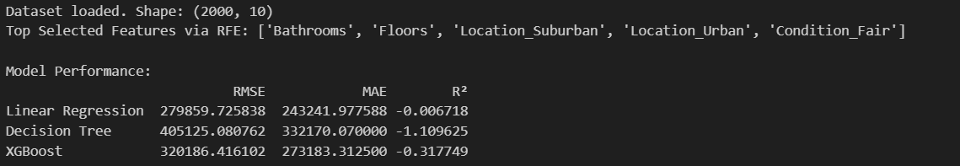
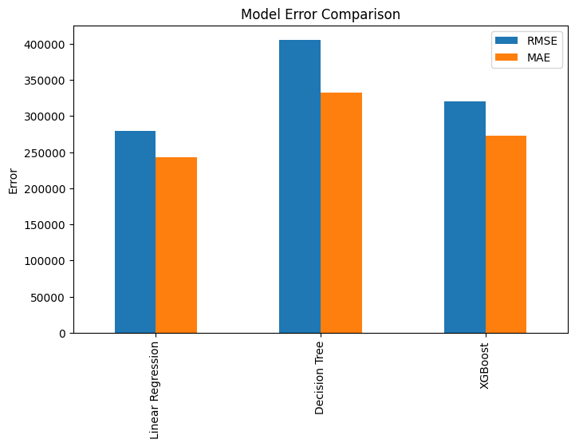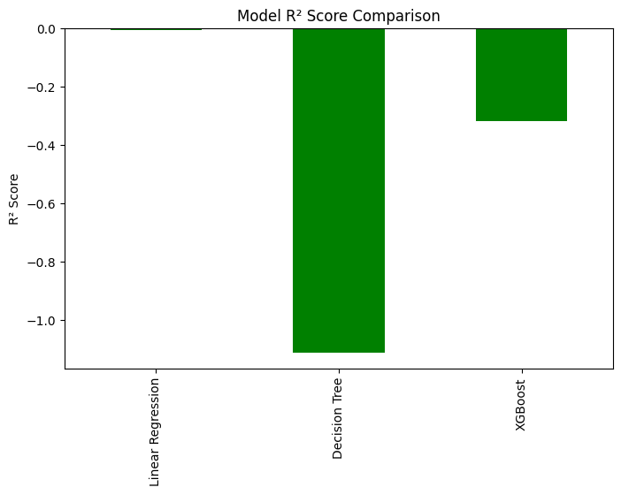
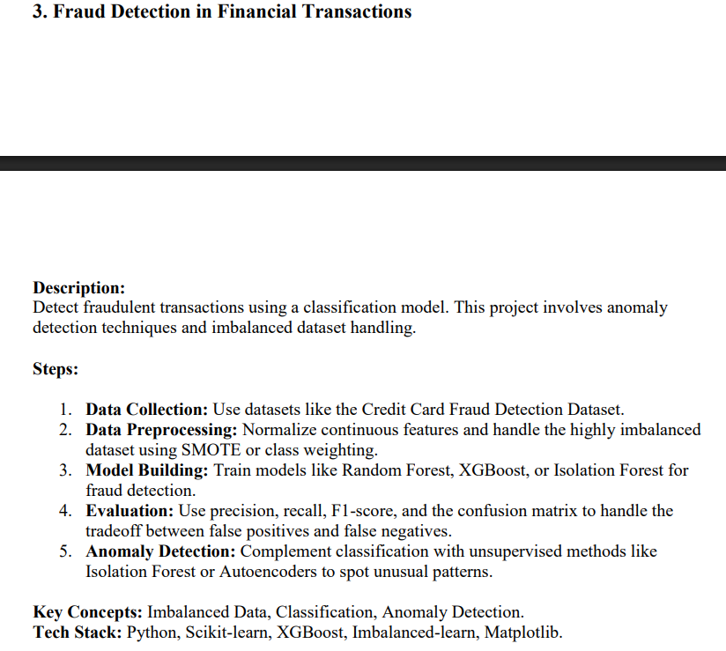
Code:
import pandas as pd
import numpy as np
import matplotlib.pyplot as plt
import seaborn as sns
from sklearn.model_selection import train_test_split
from sklearn.preprocessing import StandardScaler, OneHotEncoder
from sklearn.compose import ColumnTransformer
from sklearn.pipeline import Pipeline
from sklearn.metrics import classification_report, confusion_matrix, ConfusionMatrixDisplay

from sklearn.ensemble import RandomForestClassifier, IsolationForest
from xgboost import XGBClassifier

from imblearn.over_sampling import SMOTE
df = pd.read_csv(r"C:\\pictures\\JIGRA\\internforge\\credit_card_fraud_dataset.csv")
print("Dataset loaded. Shape:", df.shape)
print(df.head())
if 'TransactionID' in df.columns:
df.drop(columns=['TransactionID'], inplace=True)
if 'TransactionDate' in df.columns:
df['TransactionDate'] = pd.to_datetime(df['TransactionDate'], errors='coerce')
df['Year'] = df['TransactionDate'].dt.year
df['Month'] = df['TransactionDate'].dt.month
df['Day'] = df['TransactionDate'].dt.day
df['Hour'] = df['TransactionDate'].dt.hour
df.drop(columns=['TransactionDate'], inplace=True)
target = 'IsFraud'
X = df.drop(columns=[target])
y = df[target]
num_features = ['Amount', 'Year', 'Month', 'Day', 'Hour']
cat_features = ['MerchantID', 'TransactionType', 'Location']
numeric_transformer = StandardScaler()
categorical_transformer = OneHotEncoder(handle_unknown='ignore', sparse_output=False)
preprocessor = ColumnTransformer(
transformers=[
('num', numeric_transformer, num_features),
('cat', categorical_transformer, cat_features)
])
X_train, X_test, y_train, y_test = train_test_split(
X, y, test_size=0.2, random_state=42, stratify=y)
X_train_encoded = pd.get_dummies(X_train, columns=cat_features, drop_first=True)
scaler = StandardScaler()
X_train_encoded[num_features] = scaler.fit_transform(X_train_encoded[num_features])
smote = SMOTE(random_state=42)
X_train_bal, y_train_bal = smote.fit_resample(X_train_encoded, y_train)
print("After SMOTE:", X_train_bal.shape, y_train_bal.value_counts())
X_test_encoded = pd.get_dummies(X_test, columns=cat_features, drop_first=True)
X_test_encoded = X_test_encoded.reindex(columns=X_train_encoded.columns, fill_value=0)
X_test_encoded[num_features] = scaler.transform(X_test_encoded[num_features])
rf_model = RandomForestClassifier(random_state=42)
xgb_model = XGBClassifier(random_state=42, use_label_encoder=False, eval_metric='logloss')
for name, model in [('Random Forest', rf_model), ('XGBoost', xgb_model)]
model.fit(X_train_bal, y_train_bal)
y_pred = model.predict(X_test_encoded)
print(f"\n{name} Classification Report:")
print(classification_report(y_test, y_pred))
cm = confusion_matrix(y_test, y_pred)
disp = ConfusionMatrixDisplay(confusion_matrix=cm)
disp.plot(cmap=plt.cm.Blues)
plt.title(f"{name} Confusion Matrix")
plt.show()
iso_forest = IsolationForest(contamination=0.01, random_state=42)
iso_forest.fit(X_train_encoded)
anomaly_pred = iso_forest.predict(X_test_encoded)anomaly_pred = np.where(anomaly_pred == -1, 1, 0) # 1 means Fraud

print("\nIsolation Forest Classification Report:")
print(classification_report(y_test, anomaly_pred))
cm_iso = confusion_matrix(y_test, anomaly_pred)
disp_iso = ConfusionMatrixDisplay(confusion_matrix=cm_iso)
disp_iso.plot(cmap=plt.cm.Reds)
plt.title("Isolation Forest Confusion Matrix")
plt.show()

Results: